**What is Critical Thinking?**

* [Overview](https://www.nuigalway.ie/academic-skills/)
* [Getting Started](https://www.nuigalway.ie/academic-skills/gettingstarted/)
* [Getting Organised](https://www.nuigalway.ie/academic-skills/gettingorganised/)
* [Communication Skills](https://www.nuigalway.ie/academic-skills/communicationskills/)
* [IT and Digital Skills](https://www.nuigalway.ie/academic-skills/itskills/)
* [Reading and Research Skills](https://www.nuigalway.ie/academic-skills/readingandresearch/)
* [Academic Writing](https://www.nuigalway.ie/academic-skills/academicwriting/)
* [Critical Thinking](https://www.nuigalway.ie/academic-skills/criticalthinking/)
  + [**What is Critical Thinking?**](https://www.nuigalway.ie/academic-skills/criticalthinking/whatiscriticalthinking/)
  + [How to develop your critical thinking skills](https://www.nuigalway.ie/academic-skills/criticalthinking/howtodevelopyourcriticalthinkingskills/)
  + [Evaluating arguments and evidence](https://www.nuigalway.ie/academic-skills/criticalthinking/evaluatingargumentsandevidence/)
  + [Reflective practice and reflective writing](https://www.nuigalway.ie/academic-skills/criticalthinking/reflectivepracticeandreflectivewriting/)
* [Mathematics and Statistics](https://www.nuigalway.ie/academic-skills/mathsandstats/)
* [Assignments and Exams](https://www.nuigalway.ie/academic-skills/assignmentsexams/)

Critical thinking skills are sometimes described as ‘higher order’ skills – that is, skills requiring ways of thinking that are deeper and more complex than the kind of ‘everyday’ thinking that we use to, say, cook a meal or learn our times tables.

A framework that describes different levels of thinking can be helpful to start to understand the concept of critical thinking; one of the best-known of these is Bloom’s Taxonomy of Educational Objectives (1956) – an updated version of which is shown below.

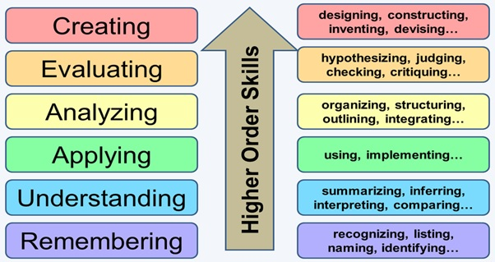

Image source: <http://ezsnips.squarespace.com/blooms-taxonomy/>

This framework suggests that remembering, understanding, and even applying facts, figures, concepts, or other learning are ‘lower order’ skills. Of course it’s important to be able to do these things, but they are just a beginning. To do really well academically, you will also need to be able to **analyse** and **evaluate** the information that you encounter in the course of your studies, and then **make inferences** or draw conclusions based upon your analysis and evaluation. These three key higher order skills are core to critical thinking. Ultimately, the aim is to create original academic work of your own (while acknowledging the ideas and work of others, of course).

**Analysis:** involves close reading or scrutiny of a piece of work to detect and identify its main points, arguments, and conclusions, and the evidence offered in support of them. Analysis often involves comparing and contrasting the work of different authors, identifying key themes or areas of contention, and/or making connections between different ideas or approaches towards the topic under consideration. Analysis may also involve the detailed examination of other data, such as the outcome of an experiment or a computer simulation.

**Evaluation:**involves assessing and probing the various points, arguments and evidence that you have found, in order to make a judgement about their credibility, relevance, and strength. It may involve considering what an author or authors have omitted, as well as what they have included, and questioning the conclusions that they have reached. Evaluation often requires you to consider how well the evidence or argument 'fits' with a particular theory.

**Inference:**involves building on your analysis and evaluation of the available information, by using them to reach a conclusion of your own. This may involve agreeing or disagreeing with the theories, arguments and conclusions of others, discussing the implications of the information that you have considered, and possibly making suggestions or recommendations for the future.

Developing these skills will make it possible for you to master the key academic skill of **reflective judgement** or the ability to make a reasoned judgement, based on the available information, while also being cognisant of the nature and limits of knowledge and knowing. As your critical thinking skills develop, you should feel more confident about creating original work of your own, knowing that your ideas rest on solid critical foundations.

The following infographic, created by NUI Galway researchers, illustrates these ideas and introduces the concept of critical thinking dispositions (see the [How to develop your critical thinking skills](http://www.nuigalway.ie/academic-skills/criticalthinking/howtodevelopyourcriticalthinkingskills/) section of the Academic Skills Hub for more about these dispositions):

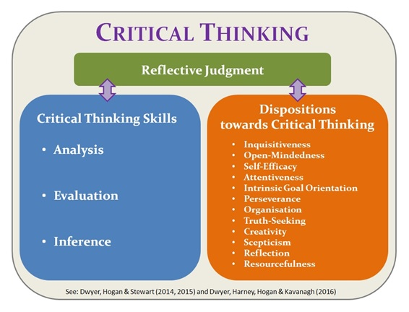

It’s really important to understand that being critical does not imply being negative. For some students, the word ‘critical’ has negative connotations, and they take it to mean that they should only find fault with an idea or a piece of work. This is incorrect. Being critical means considering things in a balanced and objective way, and using reason and logic – rather than instinct, emotion, or belief – to reach a conclusion.