[**Synthesizing different bodies of work in your literature review: The Conceptual Synthesis Excel Dump (CSED) technique**](http://www.raulpacheco.org/2016/06/synthesizing-different-bodies-of-work-in-your-literature-review-the-conceptual-synthesis-excel-dump-technique/)

Since I’m writing a series of posts on literature reviews (and undertaking a few of my own), I figured I could expand on how you can combine citation tracing, concept saturation, results’ mind-mapping with a method that Professor Elaine Campbell showcases in her excellent post “[How I use Excel to manage my literature review](https://alawuntoherself.com/2016/05/20/how-i-use-excel-to-manage-my-literature-review/)“.

I call this technique the “***Conceptual Synthesis Excel dump***” – I call it “dump” because I basically throw into the Excel file everything that is already [in my research](http://www.raulpacheco.org/2015/05/my-acwri-strategies-write-memos-about-readings-and-about-research/) and [conceptual/reflective](http://www.raulpacheco.org/2015/05/my-acwri-strategies-write-reflective-memos/) memoranda. Doing the conceptual synthesis Excel dump [as you do your reading](http://www.raulpacheco.org/2015/05/my-acwri-strategies-write-reflective-memos/) allows you to create a nice map of the literature. It also helps reach [conceptual saturation during the literature review](http://www.raulpacheco.org/2016/06/my-own-workflow-strategically-reading-and-summarizing-the-literature/).

What I am showing here is my Excel dump on bottled water. There are a number of themes (if you’re doing coding in qualitative methods, you’ll understand what I mean) that interest me:

* Fear of the tap water.
* Decisions on whether to consume tap water vs. bottled water.
* Branding water and bottled water and the use of branding techniques in promoting bottled water.
* Ethical bottled water.

I am showing three screen captures of the Excel file I created. Note that the columns I use are the following:

* **Concept** – here I list the main idea or major theme of the specific literature review.
* **Citation** – here I include the full citation (article, book, book chapter).
* **Main idea** – here I summarize the full article in a sentence or two.
* **Notes 1** – here I make notes about specific ideas or whether I agree or disagree
* **Notes 2** – same as the above
* **Notes 3** – same as the above
* **Cross-reference** – which references and citations are linked to one another.
* **Quote/quotation** – specific quotes, as per my memorandum technique, that could be useful
* **Page** – the page from where I drew the quote. Note that I can draw several quotes from same article

[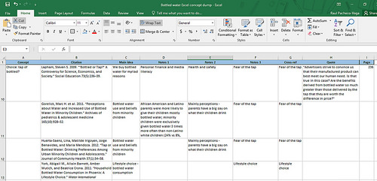](https://www.flickr.com/photos/rolexpv/27699595866/in/dateposted-public/)

[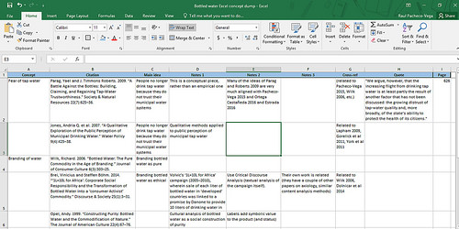](https://www.flickr.com/photos/rolexpv/27455562450/in/dateposted-public/)

[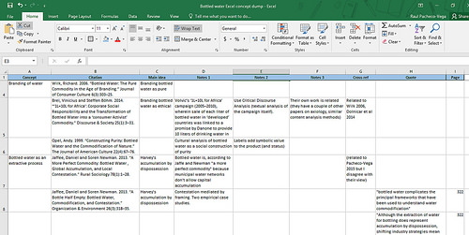](https://www.flickr.com/photos/rolexpv/27120933014/in/dateposted-public/)

My Conceptual Synthesis’ Excel dump technique is quite handy in the process of creating a literature review (both to reach concept saturation and to create the mind map). Hopefully it will be helpful to you too! I wrote this post partly as a response to the tweet below :-)

[https://pbs.twimg.com/profile_images/1043572005130375169/oieJ5K_r_normal.jpg](https://twitter.com/rebeccalinnett)

**[Rebecca J. Linnett](https://twitter.com/rebeccalinnett)**[@rebeccalinnett](https://twitter.com/rebeccalinnett)

Love this - kind of like [@raulpacheco](https://twitter.com/raulpacheco)'s memo-ing, only in spreadsheet form :-)

**[Aurélie LitReview](https://twitter.com/HowToLitReview/status/743035589474144256" \t "_blank)**[@HowToLitReview](https://twitter.com/HowToLitReview/status/743035589474144256" \t "_blank)

[How I use Excel to manage my Literature Review https://alawuntoherself.com/2016/05/20/how-i-use-excel-to-manage-my-literature-review/ … by @alawuntoherself](https://twitter.com/HowToLitReview/status/743035589474144256" \t "_blank)

[6](https://twitter.com/intent/like?tweet_id=743081183282618368" \o "Like)

[9:02 PM - Jun 15, 2016](https://twitter.com/rebeccalinnett/status/743081183282618368)

[Twitter Ads info and privacy](https://support.twitter.com/articles/20175256)

[See Rebecca J. Linnett's other Tweets](https://twitter.com/rebeccalinnett" \o "View Rebecca J. Linnett's profile on Twitter)

IMPORTANT EDIT – After many requests, I finally got around creating a [**Conceptual Synthesis Excel Dump template**](https://docs.google.com/spreadsheets/d/1O7F9TxjJp-NQZs8TD_c_UJfmaOn29jDYiLfL65Fyf1E/copy) that you can download and edit for your own purposes. I use a framing theory paper but you can adapt to your needs.

*Posted in*[academia](http://www.raulpacheco.org/category/academia/)*,*[research](http://www.raulpacheco.org/category/research/)*.*

*Tagged with*[literature review](http://www.raulpacheco.org/tag/literature-review/)*,*[research](http://www.raulpacheco.org/tag/research/)*,*[writing](http://www.raulpacheco.org/tag/writing/)*.*

[No comments](http://www.raulpacheco.org/2016/06/synthesizing-different-bodies-of-work-in-your-literature-review-the-conceptual-synthesis-excel-dump-technique/#respond)

*By* [Raul Pacheco-Vega](http://www.raulpacheco.org/author/admin/) *–* June 17, 2016