**[My Fall 2015 weekly schedule](http://www.raulpacheco.org/2015/08/my-fall-2015-weekly-schedule/" \o "Permanent link to My Fall 2015 weekly schedule)**

If you’ve followed me on Twitter or read my blog for any length of time, you’ll know that [I’m pretty rigid in my schedule](http://www.raulpacheco.org/2013/08/scheduling-my-academic-life-to-the-very-minute-my-weekly-template/). Ever since I was a child I have done everything adhering to strict deadlines and I started using calendars perhaps in my very early years. A lot of people think I have a very regimented schedule (this is the previous post where I shared mine), but this term, I built a lot more flexibility, particularly because I do want to do some fieldwork still. As you can see, I can’t [write for 2 hours every day](http://www.raulpacheco.org/2014/07/on-writing-every-day-for-two-hours-acwri/) (because I need to exercise, have breakfast and shower and drive to campus), but I still can definitely squeeze 10 hours per week of writing. [I NEED to protect my research and writing time](http://www.raulpacheco.org/2014/05/protecting-your-time-as-an-early-career-academic/) even during teaching semesters (I only teach one semester per year).

[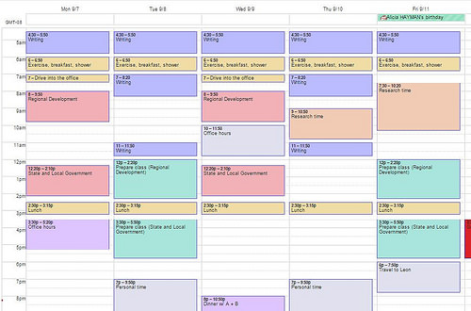](https://www.flickr.com/photos/rolexpv/20217076206/in/dateposted-public/)

You will notice two things: First, that **I still have 10 hours worth of writing time, but I have distributed them unevenly.** I still wake up at 4:30am, and I still exercise, and spend time out with my friends. But all the white gaps you see? Those are for the things that I need to do at some point, including fieldwork. So if I need to go on the field on Friday, I’ll prepare my lecture on the Tuesday. And second, that **I have not scheduled EVERY SINGLE MINUTE** of my day. I have left ample time for contingencies. I still protect my time, particularly writing and class preparation, and self-care, but the rest of the time? I leave room for contingencies and potential fieldwork.

I teach 2 courses this fall, plus a lot of continuing education diploma sessions, so it will be intense, but I also believe it will be rewarding. If I need to change something, it probably will be writing in the very early morning because I still want to make it to the gym before I go to campus. I also put class preparation on the Friday so that I can clear my docket before the weekend. But if I need to do fieldwork, I’ll move it earlier in the week.

*Posted in*[environmental policy](http://www.raulpacheco.org/category/environmental-policy/)*.*

*Tagged with*[academia](http://www.raulpacheco.org/tag/academia/)*,*[organization](http://www.raulpacheco.org/tag/organization/)*,*[schedule](http://www.raulpacheco.org/tag/schedule/)*.*

[1 comment](http://www.raulpacheco.org/2015/08/my-fall-2015-weekly-schedule/#comments)

*By* [Raul Pacheco-Vega](http://www.raulpacheco.org/author/admin/) *–* August 2, 2015