I’m going to use this paper to showcase how I highlight, scribble and file my printed materials. I use Sharpie fineliners to write, Stick’n rigid plastic tabs to sort and organize and I’m testing these Faber-Castell highlighters.

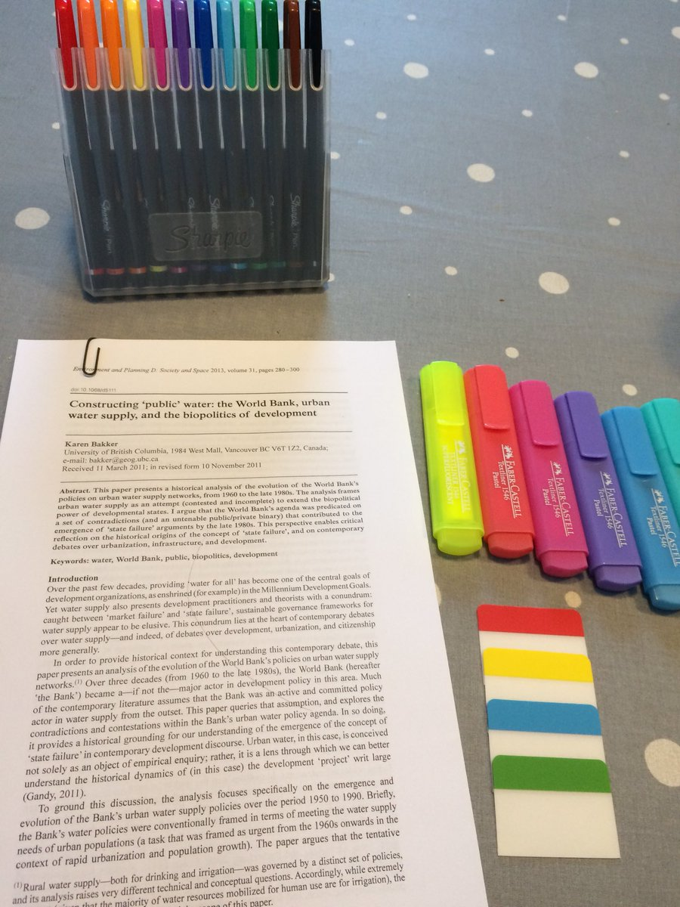

First I write the author and year on the plastic tab. I use rigid ones, other people use Post-It notes. For me, the rigidity allows for easier sorting (I file them in magazine holders labeled with the topic or name of the paper I am writing). Colour of label not relevant here.

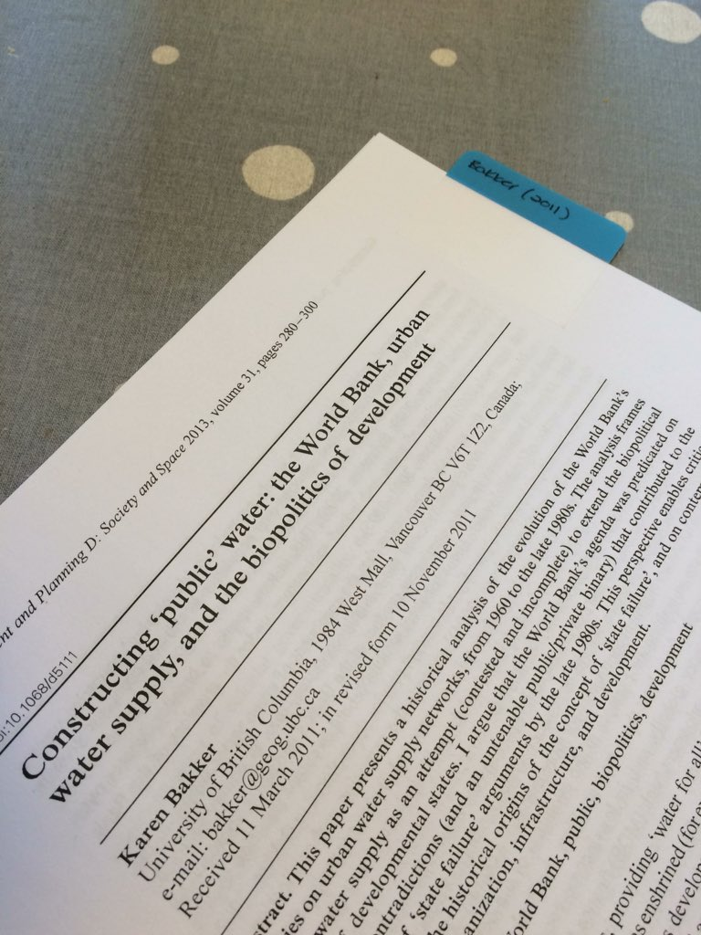

I usually go through the Abstract, Introduction and Conclusion of a paper (hence AIC) to give myself an idea of the core concepts covered (and empirics if they are included). This is a form of rapid, skimming reading and not a substitute for deeper involvement with the work.

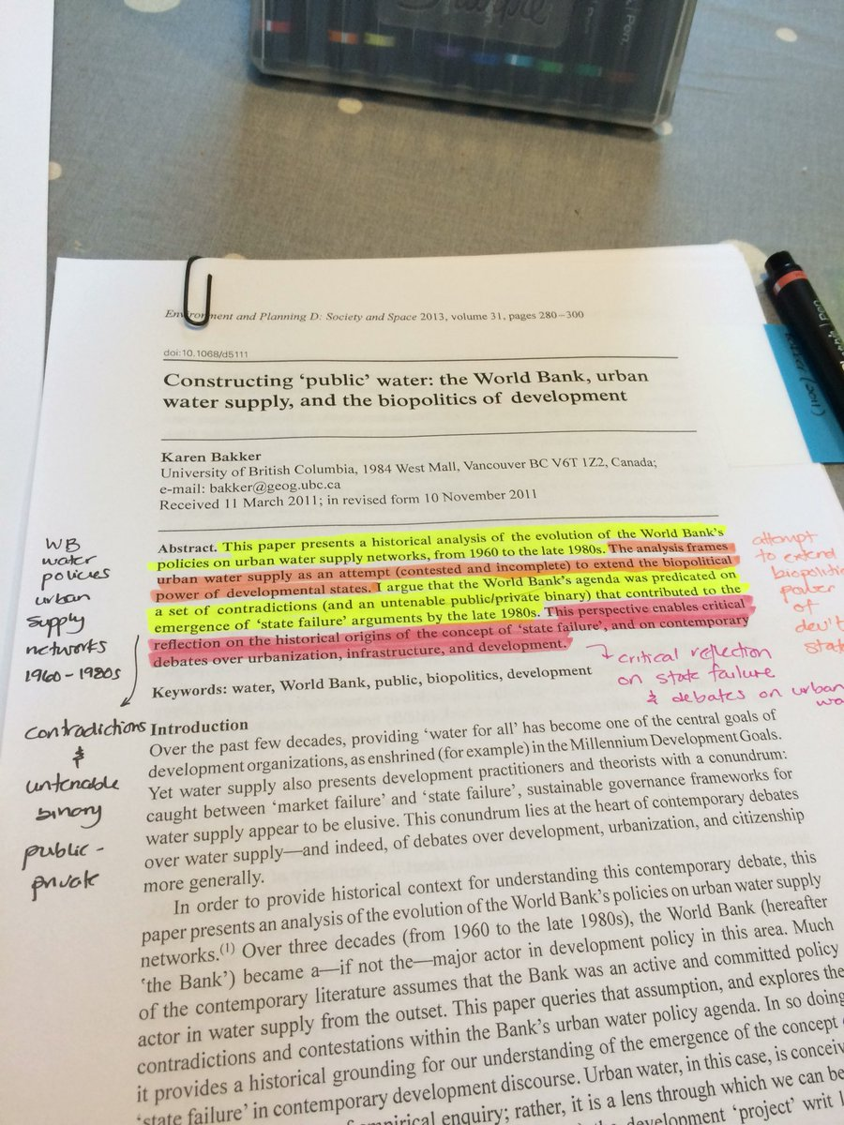

This post describes how I organize my books and printed materials [(link: http://www.raulpacheco.org/2015/09/organizing-journal-articles-and-books/) raulpacheco.org/2015/09/organi…](https://t.co/K4148sP8Nr?amp=1) and this one describes the AIC summarization method [(link: http://www.raulpacheco.org/2017/01/finding-the-most-relevant-information-in-a-paper-when-reading-a-three-step-method/) raulpacheco.org/2017/01/findin…](https://t.co/nVzDQtYocy?amp=1) I re-emphasize: AIC is NOT a substitute for deeper engagement. You may need to re-read in more depth, again.

Shocking to me, I did not have this paper in my Mendeley library even if I do have the PDF in my Dropbox. I found this out by searching my database for the author and a keyword. I use Mendeley, you can use Zotero, Refworks, Papers, Citavi, whatever. [(link: http://www.raulpacheco.org/2018/12/a-brief-guide-to-using-mendeley-as-a-reference-and-citation-manager-and-as-an-aid-to-write-scholarly-papers/) raulpacheco.org/2018/12/a-brie…](https://t.co/Gs3QK2T8ST?amp=1)

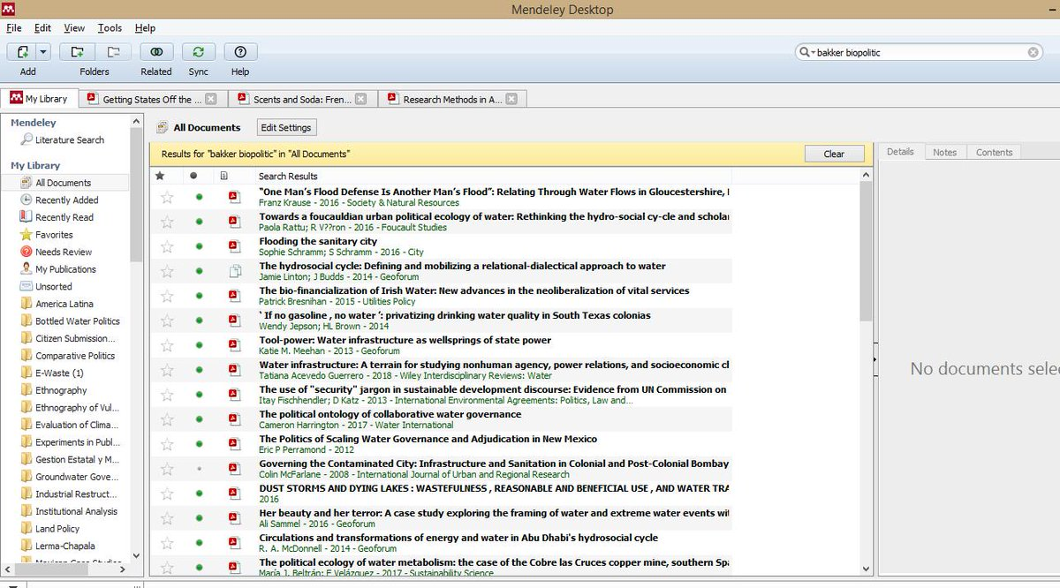

I did a second search (organizing by Author). I thought I had read EVERYTHING that Karen Bakker had published, but apparently not. What I'll do is add this PDF to my "PDFs" folder associated with this particular paper I'm writing, and have Mendeley automagically import it.

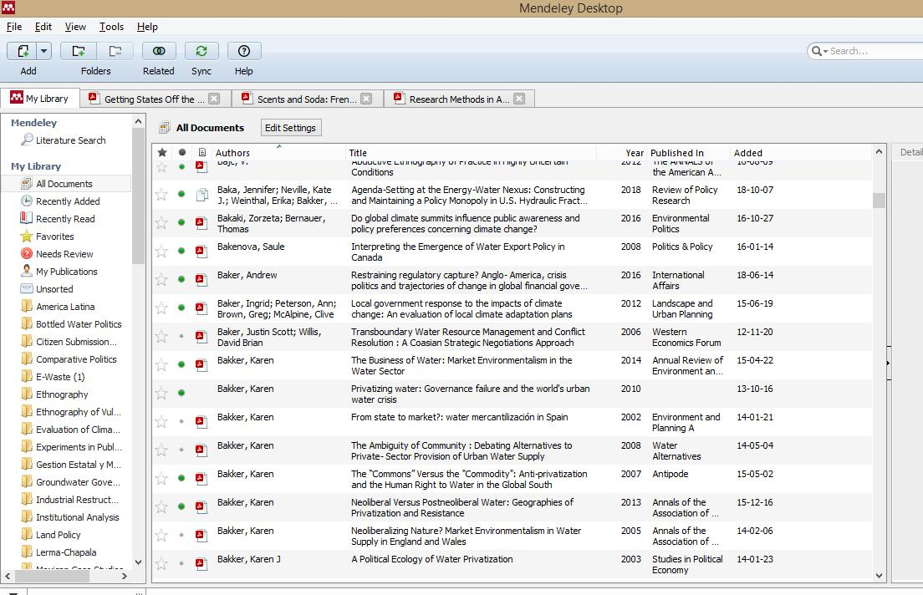

This post outlines how I organize the digital copies of my printed files [(link: http://www.raulpacheco.org/2015/09/organizing-pdfs-of-journal-articles-book-and-book-chapters/) raulpacheco.org/2015/09/organi…](https://t.co/flJVfgjTHv?amp=1) - in a previous tweet, I linked to a Mendeley guide I wrote. This guide explains how to have Mendeley "Watch A Folder" for automagical importing of PDFs. A clean reference uploaded!